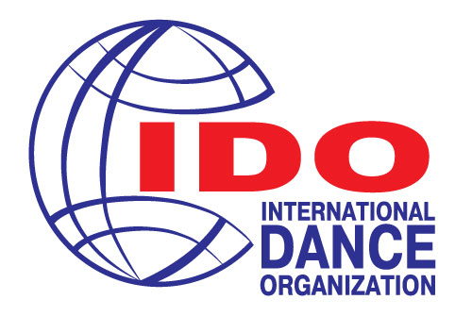
International Dance Organization
All Russia Dance Organization
Presenting:
VIII Baltic Dance OLYMPIAD
22-25 October 2020
Russian Federation, Saint-Petersburg
ACCOMODATION, TRANSFER AND VENUE
Hotel «Saint-Petersburg»
Pirogovskaya emb. 5/2,
Saint-Petersburg
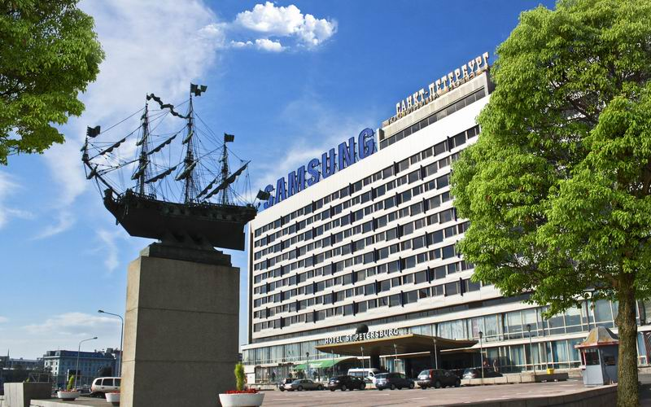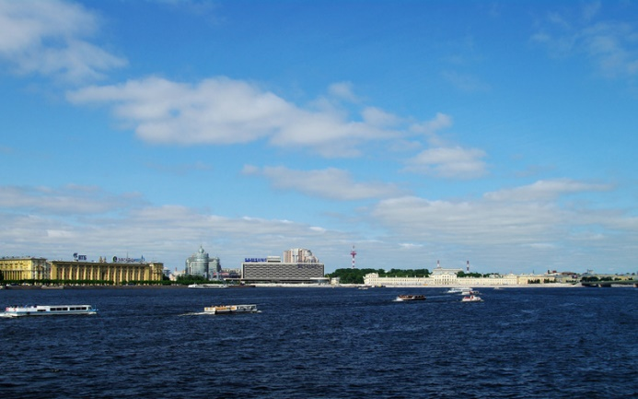
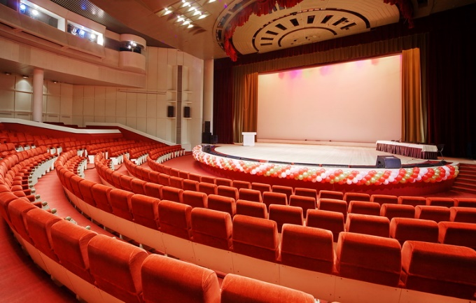

Welcome to Saint-Petersburg Hotel
The Saint-Petersburg Hotel is located in the historical center of the city, on the main Neva River Embankment and is suitable for all kinds of visitors, both leisure and business. In addition, we pride ourselves on offering the best view of the St. Petersburg historical city center.
Rated 3 Star, the Saint-Petersburg Hotel, aims at providing great value at an affordable price. We also aim to please you with our friendly and personalized service.
We are just a few meters from the famous Aurora Battle Cruiser and the Peter and Paul Fortress, both of which you can see from our rooms. The Hotel Saint-Petersburg, named after the city, offers easy access to all tourist attractions, the State Hermitage Museum, the Russian Museum, the Mikhaylovsky Castle, the Summer Garden, the Mariinsky Theatre and many, many more.
Our location is not only ideal for tourism, but also for business. Close to our hotel we have a large number of the city's business regions and main road arteries, metro, trains and public transport. It is therefore easy to use our hotel and facilities for exhibitions, conferences and conventions, receptions and banquets. We have 1450 square meters of meeting and exhibition space and a magnificent 1405 square meter, column-free, Grand Concert Hall. We offer up-to-date technical equipment for all our meeting space and everything we do and have should contribute to making your event a successful one. Hotel is the no smoking area.
Our tasty buffet breakfast is served in our main all-day dining restaurant, called the 'Bering', the breakfast is included in all our room prices. You can also enjoy a drink or a light meal in our Lobby Bar. The beverage selection should have something for everyone's desire.

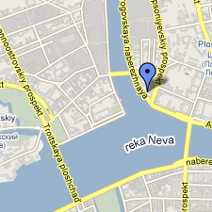
Room facilities:
- Phone line
- Satellite television
- Personal washing composition
- Wi Fi Internet access is free of charge in any room.
Hotel facilities:

- Reception 24 hours
- Storage baggage room
- Safety box
- Courier service
- Concierge service
- Booking
- Parking
- ATM
- Exchange service
- Taxi and transfer service
- Internet access
- Internet terminal
- Souvenir shop
- Laundering and ironing service

SPECIAL prices!!!
In rubles (в рублях)
 | Special offer from the organizer (Per person, Rub)  С человека | Special offer from the organizer (Per Room, Rub)  За номер | Direct price from the www  На сайте отеля  Невозвратный\возвратный  За номер
Одноместный стандарт Нева | 3300 | 3300 | 4000\4800
Двухместный стандарт Нева | 2000 | 4000 | 5900\6400
Двухместный стандарт двор | 1900 | 3800 | 5000\5500
Делюкс двор (2+2) | 2275 | 4550 | 6100\6600
Делюкс Нева (2+2) | 2700 | 5400 | 6950\7450
доп. кровать | 1300 | 1300 | 1400\1500
SPECIAL prices!!!
Rooms  (with breakfast) | Special offer from organizer (Per Room, Eur) | Special offer from organizer (Per person, Eur)
Single room Standard  (faced to Neva river) | 60 | 60
Double room Standard  (faced to Courtyard) | 70 | 35
Deluxe (2+2 sofa)  (faced to Courtyard) | 108 | 27
Deluxe (2+2 sofa)  (faced to Neva river) | 125 | 31
Additional bed | 20 | 20

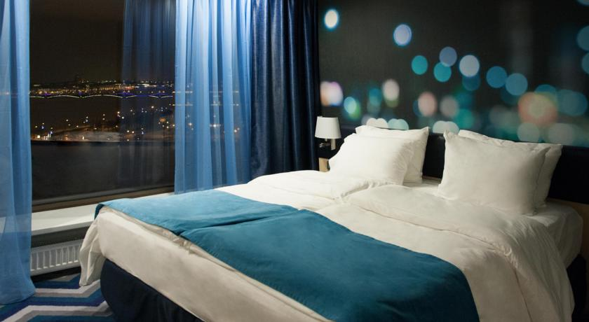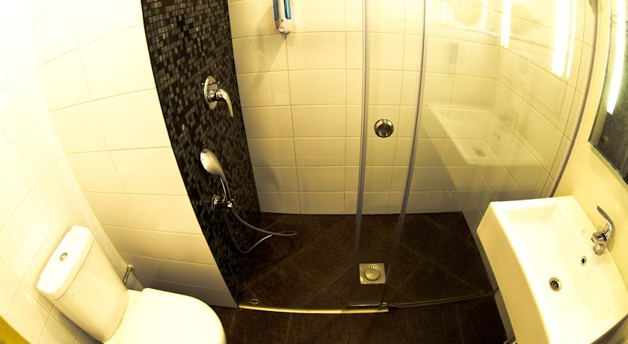

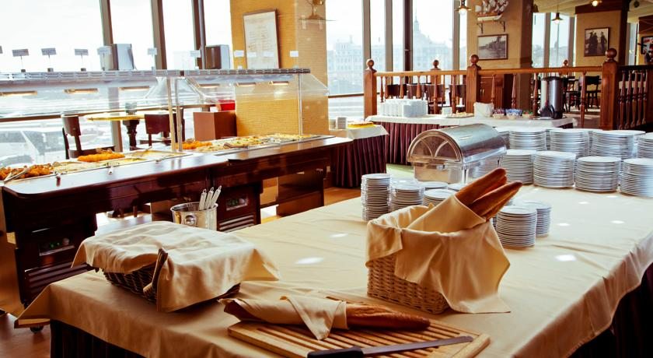
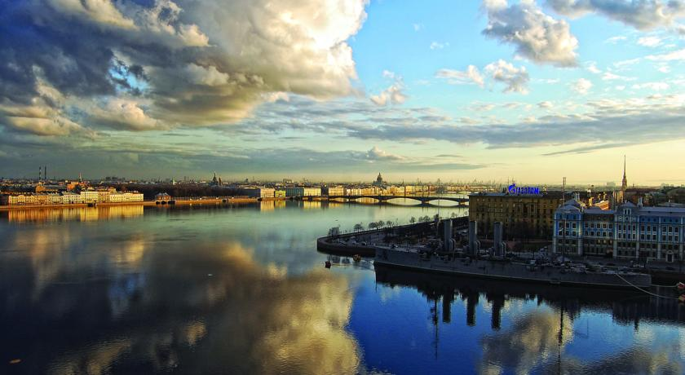

Deadline for accommodation is 15 of September!

Contacts:
- Accommodation, transfer, meals – Svetlana Volkova volkova.s92@mail.ru

Application form for accommodation
Name of the team:
Country:
Contact person:
Phone:
E-mail:

Surname, first name | Date of Arrival | Date of departure | Type of room | Number of rooms | Number of persons
Ivanova Irina  Ivanov Ivan | 21.10 | 26.10 | Double room Standard | 1 | 2
TOTAL |  |  |  | 1 | 2

* If you need an early arrival or late departure, please register separately
(Early check-in before 12:00 am - 100% of the room per day;
late check-out until 18:00 - 50% of the room per night, after 18:00 - 100%)

MEALS
Breakfast Is included in accommodation
Lunch (buffet) and Dinner (buffet) cost 10 Euro each
Please contact Svetlana Volkova volkova.s92@mail.ru
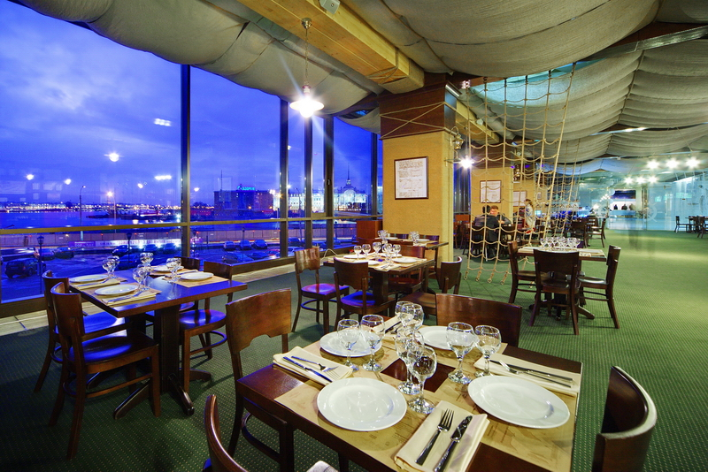
Panoramic restaurant “Bering” offers its guests a wide variety of original beer, brewed in own brewery and a great choice of beer snacks, pizzas and hot dishes! Boiled crayfish, pork shank and other culinary masterpieces would impress each connoisseur of delicious food!
Restaurant is located on a “B” floor and has a panoramic view for the historical center of Saint-Petersburg. You can feel the spirit of the city without even leaving the hotel!
Restaurant has all kinds of professional video and audio equipment, even the light show, plasma panels set all over the hall broadcast football matches and other sporting events.
Free Wi-Fi makes the place comfortable for both work and leisure.
Accommodation of every category includes exquisite buffet.
Every day, from 1 pm till 3 pm “Bering” becomes a buffet restaurant and offers a wide variety of salads, hot dishes of meat and fish, soups etc.

Transfer application form
Transfer price to one way: airport / railway Station - Hotel

Bus 50 pers (Volvo, Mercedes, Scania) - 100 Euros
Bus 53-55 pers (Volvo, Scania, Mercedes) - 150 Euros
Mini Bus 18 pers (Mercedes Sprinter, Viano) - 80 Euros
Mini Vans (Viano 5 pers/Grand Starex Urban 7 pers) - 70 Euros
Car econom class – about 25 Euros (3 pers max), check it upon the request!
Car premium class -about 35 Euros (3 pers max), check it upon the request!

The night hours from 23 pm. till 6 am. and transport to outside locations of the City (Peterhof, Pushkin, Kronstadt, Sestroretsk and ext.) – Extra payment!
Please check it upon the request before!

Apply for transfer application is possible until 15.10.2020
on Svetlana Volkova volkova.s92@mail.ru
Application form example
 | Team | Arrival | Departure
Name of Team/  Contact person/  Phone number/ email adress | SMART dance  Kristina  +37921777777  kris@gmail.ru
Arrival /  Departure  (name of the airport, railway station) |  | Pulkovo airport/  Moskovskiy  railway station | Hotel “Saint Petersburg”
Where to go |  | Hotel “Saint Petersburg” | Pulkovo airport/  Moskovskiy  railway station
Date |  | 10.10.2018. | 16.10.2018.
Flight number / time  train time |  | 13:55h  B2939 | 15:55h  B2941
Persons number |  | 14+1 baby 6years old | 14+1 baby

IF YOU HAVE CHILDREN TILL 18! IN YOUR TEAM, PLEASE SEND US WITH TRANSFER APPLICATION FORM - THE TOTAL LIST BY NAMES, DATES OF BIRTHS, PASSPORT DETAILES ALL MEMBERS OF THE TEAM AND MARK THE LEADER OF TEAM WITH TEL.NUMBER!
TICKET
700 rub or 10 euro per day

Invitation: Please contact Svetlana Volkova volkova.s92@mail.ru
Registration: IDO web site www.ido-dance.com through IDO member organizations.
Deadline – 15 of SEPTEMBER
Final Schedule: Will be published after registration on the web site
Day by day Schedule see in another document
Organizer’s office: ardo.06@mail.ru +7-925-772-60-51, 10.00 – 18.00 Moscow time
We will be glad to see you in S. Petersburg for the IDO outstanding championship!!
