Excursions in Saint-Petersburg

Saint Petersburg was founded in 1703 by Peter the Great, Russia's first and the most famous Emperor. For more than 200 years, St Petersburg was the capital of Russia and the main residence of 13 Russian Emperors.

The city combines its fascinating heritage with a distinctly European outlook and offers a vibrant cultural life and precious art collections. During the 18th and 19th centuries European and Russian architects have built great palaces, cathedrals and parks in St Petersburg. Today, over 100 palaces of Russian nobility and more than 80 museums can be visited.

St Petersburg ranks, according to the UN, among the 10 most attractive tourist destinations in the world.
About 1, 5 million foreign and 2 million Russian tourists visit the city annually.

City sightseeing tour
Duration: 3 hours
Priсe for a group from 20 till 40 persons – from 165 Euros (till 20 persons – from 110 Euros), upon request
Including: transport services, English-speaking guide and all taxes
Price for guide with another language upon request
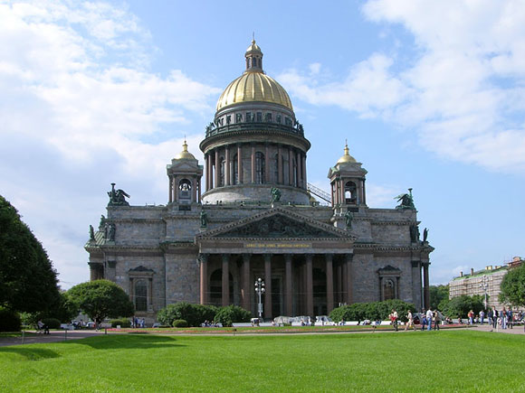
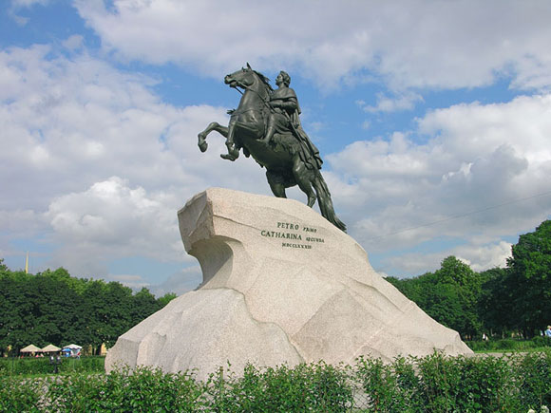
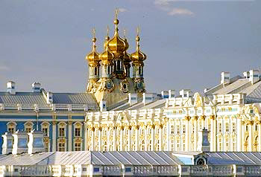

Descriptions:

The city sightseeing tour includes all major attractions of St. Petersburg. During the tour guests will be driven along the square of Arts, the Russian museums, the Cathedral of Our Savior on the Blood, Griboedov canal, Nevsky prospect, the Palace square, the Winter Palace, the spit of the Basil Island, the Menshikov Palace, the Senate square, the Bronze Horseman, St. Isaac’s Cathedral, St. Isaac’s square, The Palace Embankment, The Field of Mars, The Summer Garden, cruiser Aurora, Smolny Cathedral.

Tour to the Hermitage Art Museums
Duration: 3 hours
Price for a group from 20 till 40 persons – from 99 Euros (till 20 persons – from 88 Euros), upon request
Including: English-speaking guide and all taxes
Price for guide with another language upon request
Additional payment for entrance tickets to museum and for the transport services

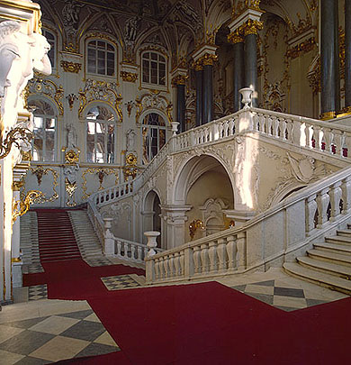
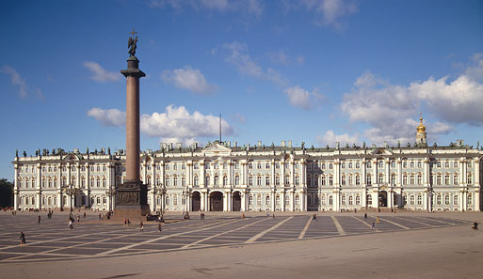
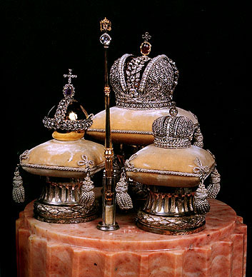

Descriptions:

The State Hermitage is situated along the embankment of the River Neva, right in the heart of St Petersburg. The leading role in this unique architectural ensemble is played by the Winter Palace, the residence of the Russian tsars that was built to the design of Francesco Bartolomeo Rastrelli in 1754-62.

The tour covers the highlights of the main collections including Italian Renaissance, Dutch art, Impressionists & Post-impressionists. It also the living quarters of the Royal family of the Romanov’s.

Tour to Russian Museum
Duration: 3 hours
Price for a group from 20 till 40 persons – from 99 Euros (till 20 persons – from 88 euros), upon request
Including: English-speaking guide and all taxes
Price for guide with another language upon request
Additional payment for entrance tickets to museum and for the transport services
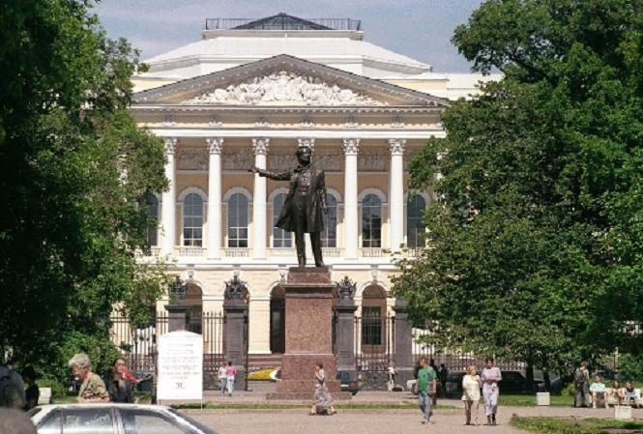
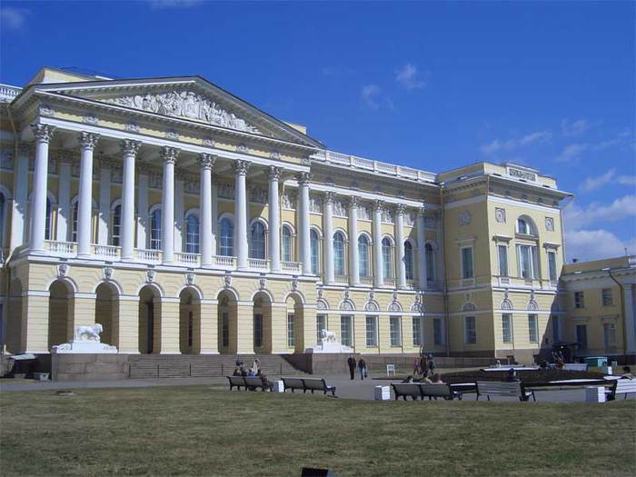
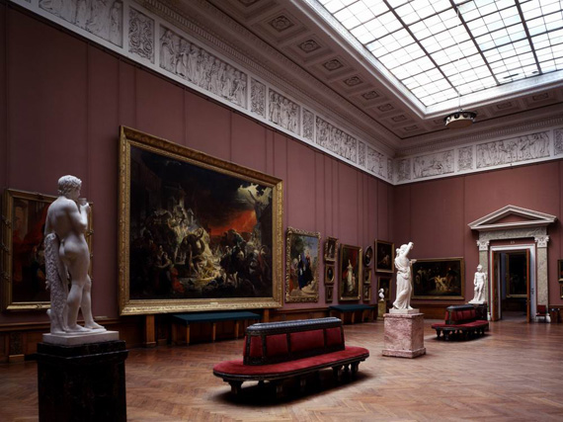

Descriptions:

The Russian Museum is the first state museum of Russian fine arts in the country. It was established in 1895 in St Petersburg by a decree of the Emperor Nicholas II. Its grand opening for visitors occurred on March 19 (March 7, the Old Style) 1898.
The Russian Museum today is a unique depository of artistic treasures, a famous restoration centre, an authoritative institute of academic research, one of the major cultural and educational centers in Russia, and a research and instructional centre of art museums of the Russian Federation, overseeing activities of 260 art museums in Russia.

THE USUPOV PALACE
Duration: 3 hours
Price for a group from 20 till 40 persons – from 176 euros (till 20 persons – from 143 euros),upon request
Including: transport services, English-speaking guide and all taxes
Price for guide with another language upon request
Additional payment for entrance tickets to museum
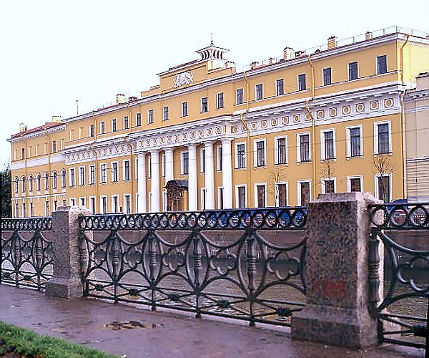
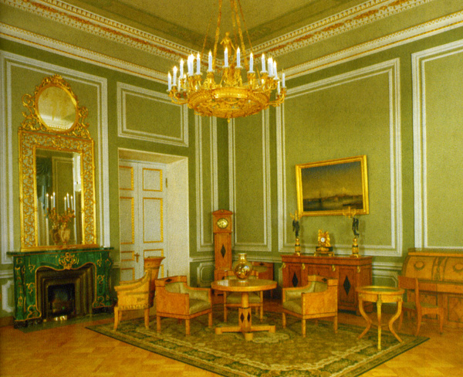
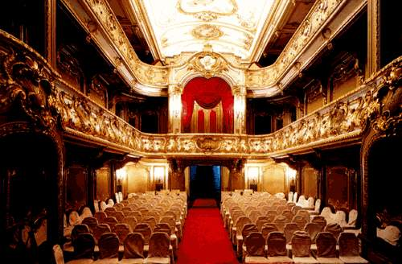

Descriptions:

This is undoubtedly one of the most beautiful and interesting palaces in St Petersburg, built in the 1740's. It was eventually bought by Prince Nikolai Yusupov in 1830 for 250,000 rubles! It was here that Prince Felix Yusupov planned and carried out the murder of Rasputin, who was lured to the Palace under the pretext of meeting Felix' young beautiful wife Irina. All the rooms are beautifully restored and full of art, and the highlight must be the exquisite private theatre, built for Zineida Yusupov, where such renowned artists as Anna Pavlova and Shaliapin have performed.

Tour of the palace (with a visit to the former wine-cellar, where Rasputin was murdered) is followed by a private concert at one of the most beautifully decorated halls. The final touch is a delicious dinner served by catering company with all the staff dressed in the costumes of the epoch!

Tour to Our Savior on the Split Blood Cathedral and to the St. Isaac’s Cathedral
Duration: 3 hours
Price for a group from 20 till 40 persons – from 165 euros (till 20 persons – from 143 euros),upon request
Including: transport services, English-speaking guide and all taxes
Price for guide with another language upon request
Additional payment for entrance tickets to museum

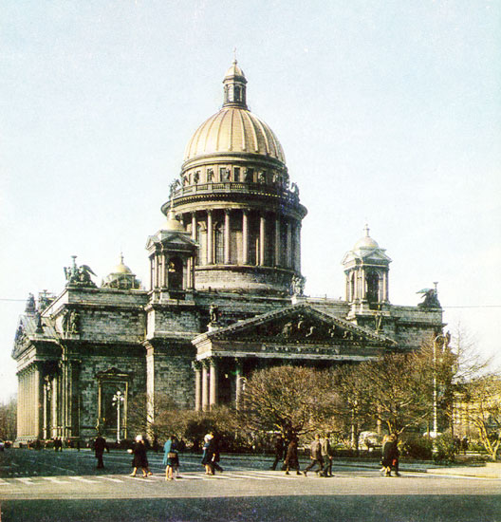
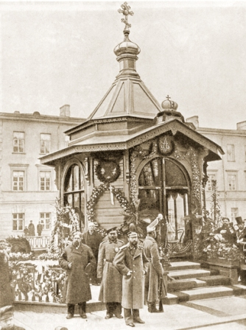
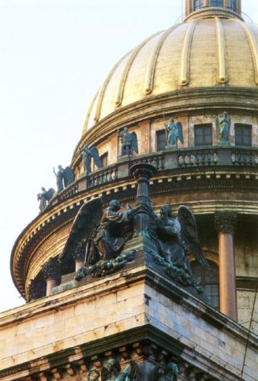
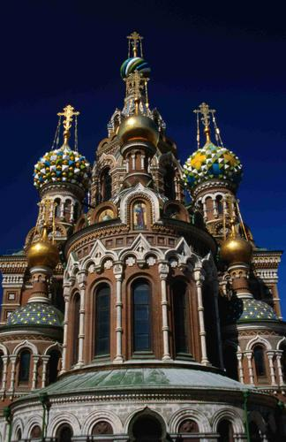
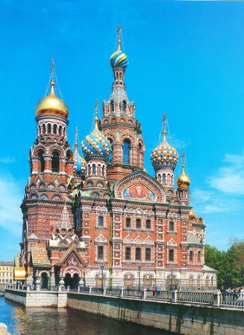

Descriptions:

The Resurrection Temple (Saviour on Spilt Blood) was being raised between 1883 and 1907 at the spot where Alexander the First was mortally wounded. The temple incorporated a slew of decorative elements typical of numerous Moscow and Yaroslav temples of the 17th centure that had been so refined both in form and shape. The temple can be truly regarded as a museum of the Russian mosaic art at the end of the 19th and the beginning of the 20th centuries, and thus as the world’s masterpiece in this capacity.

St. Isaac’s Cathedral is a remarkable architectural monument of the Late Classicism. It was St.Petersburg principal cathedral before 1917. Being raised for forty years between 1818 and 1858 by the design of August Monferrand, Isaac’s Cathedral is one of the world’s largest dome buildings with the dome diameter spanning for about 21.8 m. A magnificent view of the city heart opens up for visitors from the cathedral’s upper colonnade at a height of 43 meters.

Tour to Tsarskoe Selo with visit to the Catherine Palace and Amber room-
Duration: 4 hours
Price for a group from 20 till 40 persons – from 198 euros (till 20 persons – from 165 euros)
Including: transport services, English-speaking guide and all taxes
Price for guide with another language upon request
Additional payment for entrance tickets to museum

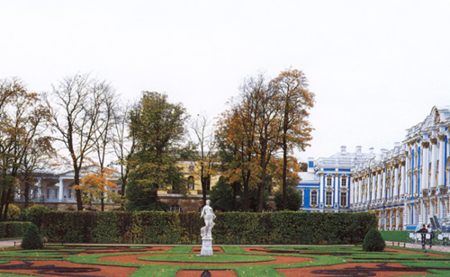
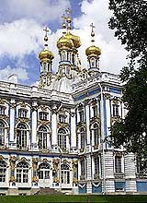
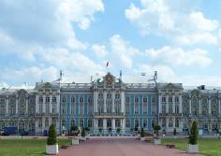

Descriptions:

The history of Tsarskoe Selo goes back to the beginning of the 18th century, when in 1708 Peter the Great presented the estate “Saari Mojs” (in future “Saarskoe Selo”) to his wife Catherine Alekseyevna.
The art collection of the Catherine Palace includes more than 20,000 objects, many of them extraordinary, such as Russian and Western European paintings from the 17th to 19th centuries, furniture designed by Chippendale, Jacob, Roentgen, Russian and Western European bronze and porcelain collection and the world-famous Amber Room.

Visit to park ensemble and the Monplaisir Palace in Peterhof
Duration: 4 hours
Price for a group from 20 till 40 persons – from 198 euros (till 20 persons – from 176 euros)
Including: transport services, English-speaking guide and all taxes
Price for guide with another language upon request
Additional payment for entrance tickets to museum
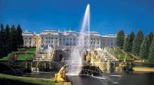
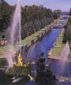
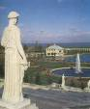

Descriptions:
The world-famous palace, fountain and park ensemble of Peterhof is an outstanding landmark of Russian artistic culture of the 18-19th centuries. Founded in the very beginning of the eighteenth century by Emperor Peter the

Great not far from his new northern capital St Petersburg, Peterhof was intended to become the most splendid official royal summer residence.

boat trip – day/night
Duration: 1 hour
Price for a group from 20 till 40 persons – from 165 euros (till 20 persons – 143 euros)
Including: transport services, English-speaking guide and all taxes
Price for guide with another language upon request

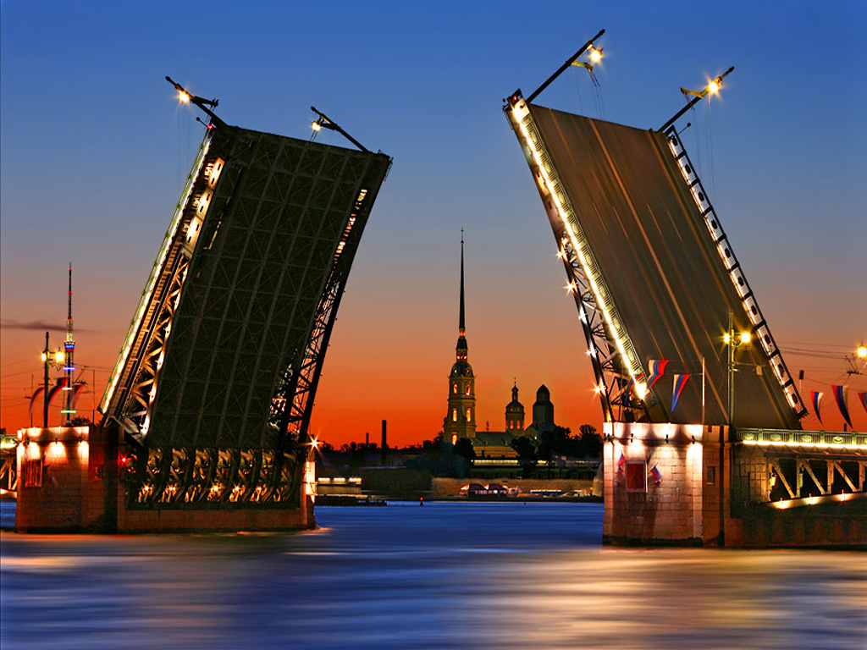
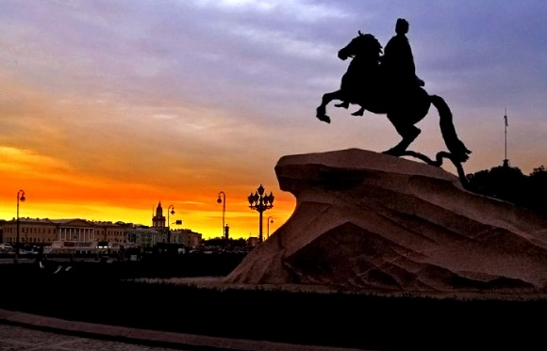
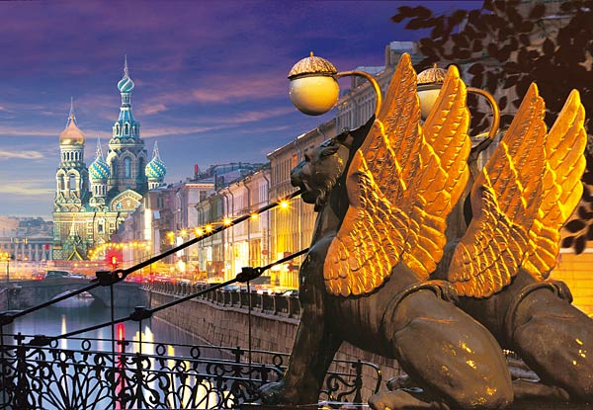

Saint-Petersburg is fairly called "North Venice". Wonderful, often unexpected sights of the famous architectural ensembles are open to you. Petersburg should be seen from water - it's difficult to find something more beautiful somewhere. There are some piers in the centre of the city where you can start you traveling from. We can suggest trips with interesting route in the historical part of the city: the Fontanka River, the Moika River, popular trips during White Nights; also trips with going out to the Finnish bay.

