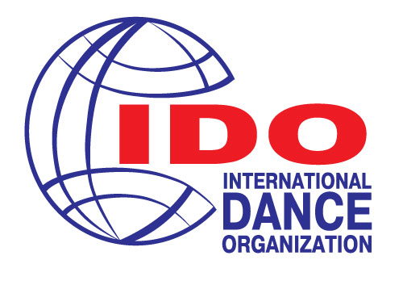

IDO European Championships
IDO World Championships &Cups
VI Baltic Dance OLYMPIAD, Sankt-Petersburg
11-14 October 2018
Tentative Schedule

 |  | 1-st Day 11 October | 2-nd Day 12 October | 3-rd Day 13 October | 4-th Day 14 October
Jazz dance  European IDO | Solo female | Mini Kids, Children |  | Junior | Adults, Adults2
 | Solo Male | Mini Kids, Children |  | Junior | Adults, Adults2
 | Duos | Mini Kids, Children |  | Junior | Adults, Adults2
 | Small Group |  | Mini Kids, Children |  | Junior, Adults, Adults2
 | Formation |  | Mini Kids, Children |  | Junior, Adults, Adults2
Modern dance\Contemporary  European IDO | Solo female | Junior | Children, Adults2 | Adults
 | Solo Male |  | Children, Junior, Adults2 | Adults
 | Duos |  | Children, Junior, Adults2 |  | Adults
 | Small Group | Children | Adults2 | Junior | Adults
 | Formation | Children | Adults2 | Junior | Adults
Ballet  European IDO | Solo female | Adults | Junior | Mini kids, Children
 | Solo Male | Adults | Junior | Mini kids, Children
 | Duos | Adults | Junior | Mini kids, Children
 | Small Group | Adults | Junior | Mini kids, Children
 | Formation | Adults | Junior | Mini kids, Children
Acrobatic dance  European IDO | Solo female | Junior | Mini kids, Children, Adults
 | Solo Male | Junior | Mini kids, Children, Adults
 | Duos | Junior | Mini kids, Children, Adults
 | Small Group | Junior | Mini kids, Children, Adults
 | Formation | Junior | Mini kids, Children, Adults
Show Dance  World IDO Cup | Solo female | Mini kids, Children | Junior | Adults, Adults 2
 | Solo Male | Mini Kids, Children | Junior | Adults, Adults 2
 | Duos | Mini kids, Children | Junior | Adults, Adults 2
 | Small Group | Mini kids, Children | Junior | Adults, Adults 2
 | Formation | Mini kids, Children | Junior | Adults, Adults 2
Tap Dance  World IDO Cup | Solo female |  |  | All ages:  Mini kids  Children  Junior  Adults  Adults 2
 | Solo Male
 | Duos
 | Trio
 | Small Group
 | Formation
Oriental  World Cup IDO | Solo female |  |  | All ages:  Mini kids, Children  Junior, Adults  Adults 2, Seniors
 | Duos
 | Small Group
 | Formation
Oriental Folk  European IDO | Solo female |  | All ages:  Mini kids  Children  Junior  Adults  Adults 2
 | Solo Male
 | Duos
 | Small Group
 | Formation
Oriental Show  World Championship  IDO | Solo female |  |  |  | All ages:  Mini kids  Children  Junior  Adults  Adults 2
 | Solo Male
 | Duos
 | Small Group
 | Formation

