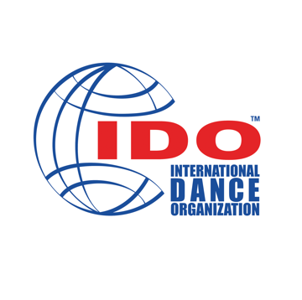
IDO CHECK SHEET FOR
MOCK JUDGING EXAM

CANDIDATE

First Name: |  |  |  |  |  |  | Surname:
E-mail: |  |  |  |  |  | Date of Birth: |  |  | Country of Citizenship:
Name of Examiner:

Name Lecturer: |  |  |  |  |  |  | Name of Proctor:
Date of Passed Theoretical Exam: |  |  |  |  |  |  |  |  |  | Date of Passed Supplementary Exam:
Candidate’s Signature: |  |  |  |  |  |  |  |  | Date:
MOCK JUDGING

Date: |  |  |  |  |  | Competition: |  |  | Location:
Name of Examiner (mock judging):

During the Competition, and while mock judging, did the applicant:

1. | …attend the required judge’s seminar prior to the competition? |  |  |  |  |  |  |  |  | Yes |  |  | No
2. | …arrive at least 30 minutes before the start of mock judging, to ensure  everything was prepared and in order? |  |  |  |  |  |  |  |  | Yes |  |  | No
3. | …dress appropriately for the competition? |  |  |  |  |  |  |  |  | Yes |  |  | No
4. | …mark/score neatly and legibly in ink? |  |  |  |  |  |  |  |  | Yes |  |  | No
5. | …appear confident in what they were doing? |  |  |  |  |  |  |  |  | Yes |  |  | No
6. | …show any signs of “home judging”? |  |  |  |  |  |  |  |  | Yes |  |  | No
7. | …know how to use the “W” and “D” in disqualification? |  |  |  |  |  |  |  |  | Yes |  |  | No
8. | …use the “W” and “D” when other judges noticed the infraction? |  |  |  |  |  |  |  |  | Yes |  |  | No
9. | …understand the practice and procedure for a “Re-Dance” when instructed  to do so by the Chairperson? |  |  |  |  |  |  |  |  | Yes |  |  | No
10. | …sign their score sheet in the proper manner? |  |  |  |  |  |  |  |  | Yes |  |  | No
11. | …make corrections as prescribed in the IDO Rules Book? |  |  |  |  |  |  |  |  | Yes |  |  | No
12. | …have too many dancers tied with the same score? |  |  |  |  |  |  |  |  | Yes |  |  | No
13. | … able to mark quickly and efficiently without conferring with others? |  |  |  |  |  |  |  |  | Yes |  |  | No
14. | …follow the Rules regarding ethics and conduct during the week? |  |  |  |  |  |  |  |  | Yes |  |  | No
15. | …familiar with the IDO judging system used at the competition? |  |  |  |  |  |  |  |  | Yes |  |  | No
TOTAL 9 YES / NO)
Eliminatory criteria are: 1, 2, 6, 14, and 15
Success in marking (all rounds before finals, minimum passing is 60%, or 9 YES. |  |  |  |  |  |  |  |  |  |  |  |  | %
Success in marking (final rounds) |  |  |  |  |  |  | SATISFACTORY
 |  |  |  |  |  |  | EXCELLENT
Examiner’s Comment(s) on Marking:
Disciplines the applicant judged, check all that apply:
 |  | Female |  |  | Male |  | Duo / Couple | Trio/Group |  |  |  | Formation
Mini Kids
Children
Junior 1
Junior 2
Adult 1
Adult 2
Production
General Comments about the Candidate:
Final Recommendation to the Adjudication Committee:
Pass Mock Exam
Re-Do Mock Exam |  |  |  | Specific Discipline or Age Division?
Failed Mock Exam
Adjudicators Sheets with scores and evaluation will be sent to the IDO Adjudication Committee via: |  |  |  |  |  |  | - E-mail  - Post  - In Person  - Other
Signature of the Examiner:

Please send this form via E-mail to the IDO Adjudication Director at:

adjudication@ido-dance.com

